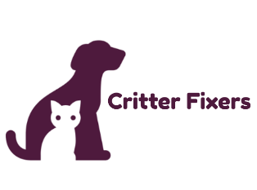
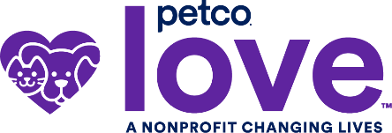

FOR IMMEDIATE RELEASE

Contact: Chantele Gonzalez, Critter Fixers, (615) 682-3363, fixmycritter@gmail.com
Crystal Bugary, Petco Love, media@petcolove.org

National Nonprofit Petco Love Invests in Critter Fixers to Help
Increase Access to Veterinary Care for Pets in Robertson County

Springfield, TN (May 01, 2026) – Critter Fixers is set to receive a $1,000 grant investment from national nonprofit Petco Love in support of their lifesaving work for pets in Robertson County.

Petco Love is a national nonprofit leading change for pets by harnessing the power of love to make communities and pet families closer, stronger, and healthier. Since its founding in 1999, Petco Love has invested nearly $433 million in adoption and other lifesaving efforts. And Petco Love helps find loving homes for pets in partnership with Petco and more than 4,000 organizations — like ours — across North America, with more than 7.1 million pets adopted and counting.

The investment in Critter Fixers is part of more than $1.2M in grants recently announced by Petco Love for nearly 200 spay/neuter clinics and other low-cost veterinary care providers to help increase access to veterinary care for pets in their communities. The lifesaving investments are also being granted to reduce economic euthanasia, and the surrender of pets to shelters when families are not able to afford needed veterinary treatment.
“Petco Love knows pets are family and we strive to take care of them the best we can, though the reality is not everyone has equal access to veterinary care as many pet parents face difficult financial times,” said Chelsea Staley, President of Petco Love. “That’s why we are proud to support our partner animal welfare organizations in providing helpful services in their communities, so we can keep pets and their families together.”
“Our partnership with Petco Love gives us the resources needed to help even more pets in our community and continue our lifesaving work,” said Chantele Gonzalez, Executive Director, Critter Fixers.
As part of Petco Love’s mission to make pet families healthier and increase access to veterinary care, through its Vaccinated and Loved campaign, Petco Love reached a significant milestone of distributing four million free pet vaccines for family pets in February 2026. The campaign was launched in 2021, encouraging Petco Love animal welfare partners to host free vaccine clinics.
Critter Fixers is a nonprofit organization that provides affordable spay/neuter and wellness services to cats and dogs in the northern middle Tennessee area. Since 2018, Critter Fixers has worked towards its goal of opening a brick-and-mortar facility and achieved it in August 2025. Critter Fixers has helped over 4,000 cats and dogs receive surgery since 2018, with over 2,800 of those surgeries performed since the opening of their facility in 2025.
For more information about Critter Fixers, visit spayrobertson.org. Learn more about Petco Love here: petcolove.org.
###

About Critter Fixers
Critter Fixers, started in 2018, with the goal of providing affordable spay and neuter services to Robertson County, TN. Beginning as an all-volunteer organization with the ability to help approximately 30 animals per month and growing to a fully staffed, brick and mortar facility that serves over 400 animals per month. Critter Fixers has helped over 4,000 cats and dogs receive surgery since 2018, with over 2,800 of those surgeries performed since the opening of their facility in August of 2025. Critter Fixers believes that preventative services should be affordable and available to all families, regardless of financial standings. Healthy pets contribute to healthy communities. Visit spayrobertson.org for more information. Follow us on Facebook, Instagram and TikTok.

About Petco Love
Petco Love is a life-changing nonprofit organization that makes communities and pet families closer, stronger, and healthier. Since 1999, we’ve empowered more than 4,000 animal welfare partners to drive lifesaving change alongside us – investing nearly $433 million in adoption and other lifesaving efforts. We’ve helped find loving homes for more than 7.1 million pets in partnership with Petco and organizations nationwide. Our love for pets drives us to lead with innovation, creating Petco Love Lost to reunite lost pets. Visit Petco Love and follow us on Facebook, Instagram, LinkedIn, and TikTok.

